Team name: | Carezad Rizzler
Affiliation: | Princess Chulabhorn Science  High School Nakhon Si Thammarat | Name of Team leader: | Thammanit Nooyimsai
Field of study: ☐ Science ☐ Physics ☐ Chemistry ☐ Biology ☒ Other: Engineering
Research title: | A notification and shutdown system for water pumps using Internet of Things (IoT) technology.
<Research Objective>
The primary research objective is to develop an IoT-based system that can monitor and control water pumps, automatically alerting users and shutting down the pump in cases of abnormal operation, such as dry running (pump operation without water flow) or excessive power consumption. The system aims to prevent pump damage, reduce maintenance costs, conserve energy, and mitigate the risk of electrical fires. The project also seeks to collect and analyze pump operation data to enhance efficiency and predict potential failures.
<Research Methods>
- Hardware Development: The system will be built using an ESP-8266 microcontroller board, flow sensors, power monitoring modules, relays, and other electronic components. The hardware will be integrated into a compact and user-friendly enclosure.
- Software Development: The project will involve programming the ESP-8266 to interface with the sensors, process data, and communicate with Blynk and Line applications for user notifications and control. Additionally, code will be written to log data to Google Sheets for further analysis.
- System Testing: The functionality and performance of the system will be rigorously tested under various operating conditions to ensure reliability and accuracy.
<Research Conclusion>
The research anticipates that the developed system will effectively detect and prevent abnormal pump operation, leading to the following outcomes:
- Reduced pump maintenance and repair costs
- Extended pump lifespan
- Prevention of electrical fires and associated risks
- Improved pump efficiency through data analysis
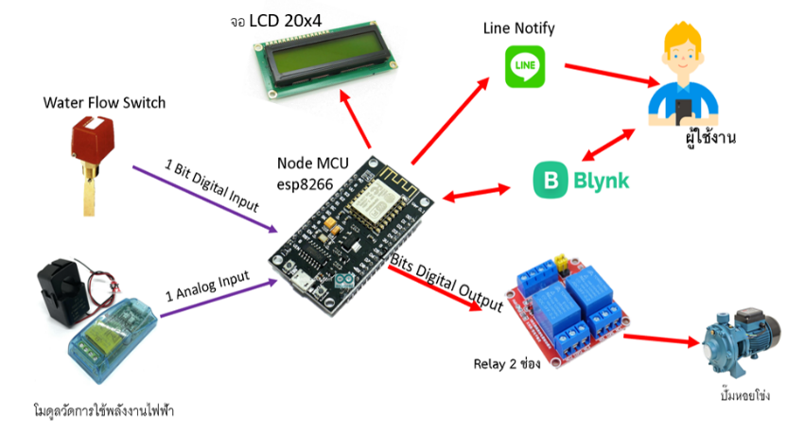
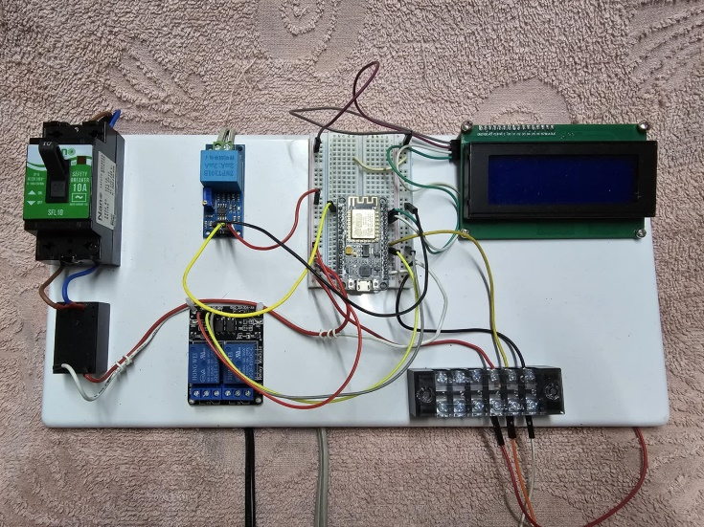
The project's findings are expected to contribute to the advancement of IoT applications in water pump management, offering a practical and cost-effective solution for enhancing pump reliability, safety, and energy efficiency.
AC Current Sensor Module
Centrifugal Pump
User

